**NORTH WEST REGIONAL COLLEGE**

**DEPARTMENT OF SCIENCE TECHNOLOGY AND CREATIVE INDUSTRIES**

**WORK BASED LEARNING - WEEKLY REPORT**

**NAME:** Sean Carlin

**REPORT NO:** 8 **DATE:** 24/04/2020

Please use the space below to give details of your activities for this report period. Your outline should include - in as much detail as possible, **a breakdown of activity by project**. You should aim to address areas such as perceived organisational benefits, desired outcomes and deliverables.

For each project that you are working on – you should indicate the title, progress, targets met and expected completion date.

**Summary of activities:**

Using my solution these past couple of weeks have been a challenge since I don’t exactly know where my program has reached in a matter of blocks, for example login block, or payment block. Luckily Vectron have their own software to enable this feature called *TCP Logviewer.*  However, for this program to connect to my computer, I must create a method that enables a *‘socket´* which is a key communication method for computers with different programs. You can see in Figure 1 overleaf that the connection variable called a ‘logsocket’ is what creates the connection to my computer via Vectron’s API function called *‘vpos.communication.Socket’.*

How does my solution know how to log you may ask? The logit function in figure one sends the data straight to TCP Logviewer. In figure 2 you can see an example of the logit code being used whilst logging near the end of the script. Once my solution successfully runs and logs everything correctly, it will look like this;

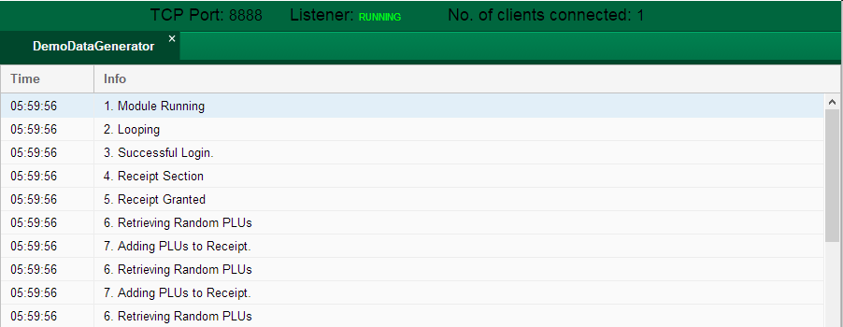

**Comments on progress:**

This week was a huge step in progression, my solution is nearing completion. Getting to use a separate software to log my program came in very handy, it also expanded my knowledge with doing the basics for created software solutions. Another key technique I learned this week was the use of Sockets, something I never heard of before even during my software development course.

**Planned tasks:**

* Go through the logging and ensure everything is logged.
* Make sure everything is clean and tidy.
* Start to tie up lose ends within my solution.

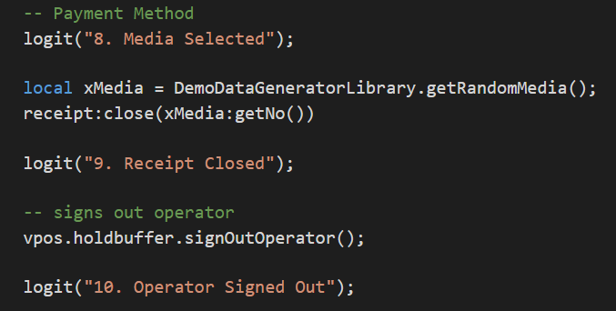

**Figure 2**

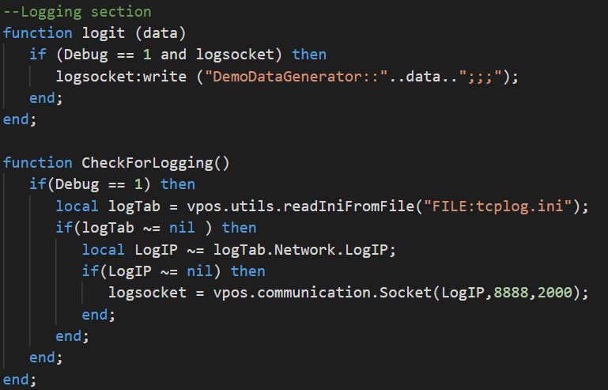

**Figure 1**